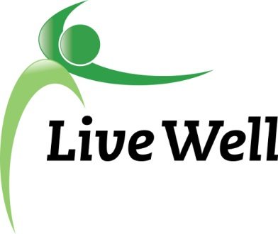
AGENDA

Healthy Food for All Work Group

Lawrence Public Library, Meeting Room A, KS 66044-3701, United States

10:00am – 11:30am, Wednesday, January 10th, 2017

Agenda items | Notes | Action Items
- Introductions | - Share agency accomplishment pertaining to HFFA work. Include:  - Who, what, where, when, any partners, number of participants, description  - Collective representation of Student Affairs at KU is striving to help students receive better access to food, research the prevalence of food insecurity on campus, and to create a meal sharing plan.  - Edgewood staff has completed a five week cooking class in December. Six families participated.  - WIC has started a program where clients will receive a card that will allow them to receive food benefits  - Common Ground has won a 10 year sustainable success award and has received a grant that will allow for evaluation of the current gardens in Lawrence.  - Stock Healthy Shop Healthy has received their grant to continue on with the initiative.
- Announcements | - New Mission: ““Leading a movement to build communities that support the health and well-being of all.”  - Meeting time change  Meeting Time Change: Tuesday-Thursday around 4 PM. Sending out doodle poll to establish a time that works for everyone.  - NationBuilder- Update  Executive team using this as a tool to schedule meetings and hold a database of group members.  - Community Health Assessment- Update:  - Access to healthy food and physical activity  - Behavioral health  - Poverty and lack of good-paying jobs  - Safe and affordable housing  The overarching theme in the Community Health Assessment is looking at discrimination and equity within the four priority points. | Kelsey
- Subcommittee Break out session (30 minutes)  Pantry: Sue, Christina, Jessica, Connie, Gwen, Liz  Corner stores: Michelle, Helen, Melissa, Kelsey, Brooke | Points of Discussion:  - Continued work on projects  - Intern projects-submit to Kelsey  - Action items moving forward-Specific assignments.  Pantry: FuelGood Pantries introductory materials are being finalized. Beginning the process of approaching pantries to work through forms and recruit for healthy pantry. Will continue to look into Gran Funding  Corner Stores: Have recruited Communications coordinator support and finalizing Community Coordinator position description. Meeting to discuss opportunities to reach groups within the community that might have the right community member interested.  Next steps are re-approaching store location with suggested changes, do in-store customer feedback forms, and sending out coupon incentive for survey participants. | Kali: Finalize the FuelGood Pantry Checklist and Healthy Pantry Guidelines  Connie & Alzieren- will be doing boots on the ground work with pantry  Michelle, Kelsey, Susie, Kali
- Subcommittee report to group | Small report back on discussion and action steps
- Additional updates | - Announcements for the group  In March and April Sunrise Kitchen will start the Nutrition and Health Series.  - Meeting location for next meeting?
- Adjourned

